**Project Management Capstone**

**Project: - Launch and Growth of Zoom**

**Section 5. Design Thinking**

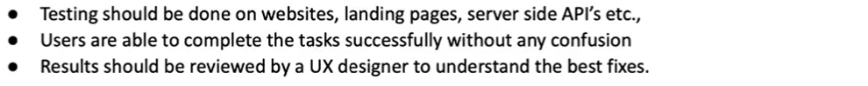

**Section 6. Setup PMO**

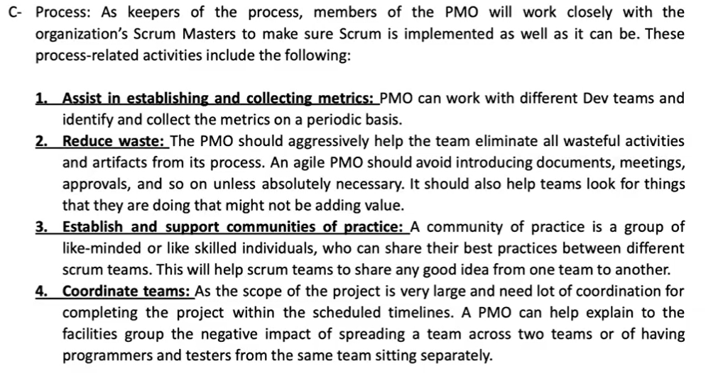

**Documents Required:**

* **WEEKLY REPORTS**
* **STATUS REPORTS**
* **MINUTES OF MEETING**
* **SUMMARY OF CHNAGE REQUESTS**
* **EXCEPTION REPORTS**
* **EARNED VALUE REPORTS**
* **RISK REPORTS**